API Security Checklist
Every API route on Eartigo that touches personal data, farm intelligence data, or financial data must satisfy all of the following controls. This is not a best-practice list — every item marked Required is a mandatory baseline before any route goes to production.
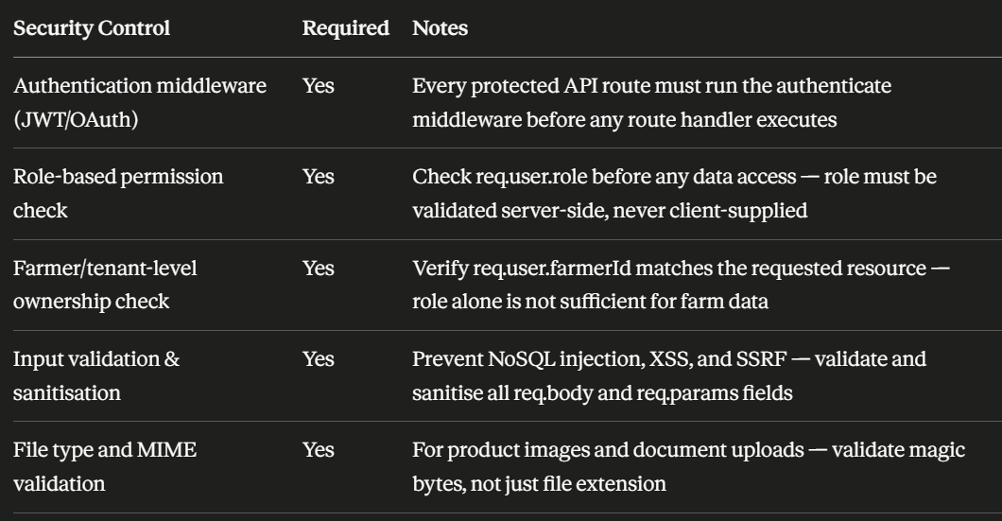
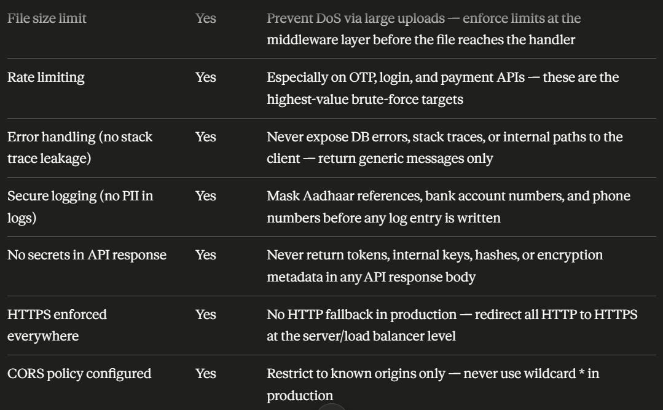

Eartigo-Specific API Rules
Every API endpoint that handles farmer financial data or farm intelligence data must verify all four of the following, in this order, before executing any database query:
- req.user.id — is there an authenticated user attached to this request?
- req.user.role — does this role have permission to perform this action on this resource type?
- req.user.farmerId — does this user own the farm resource being requested?
- req.params.id / req.body fields — does this specific record belong to this user?
Skipping any one of these creates a distinct vulnerability class. Role checks without ownership checks allow horizontal privilege escalation. Ownership checks without role checks allow a farmer to access admin-only operations on their own data.

Secure Farm Boundary Access — Example
BAD — only checks login, not role or ownership:
// BAD
if (!req.user) return res.status(401).json({ message: "Unauthorized" });
const farm = await Farm.findById(req.params.farmId);
return res.json(farm); // Any logged-in user gets any farm's data

GOOD — checks login, role, AND ownership:

// GOOD
if (!req.user) return res.status(401).json({ message: "Unauthorized" });
if (!allowedRoles.includes(req.user.role)) return res.status(403).json({ message: "Forbidden" });
const farm = await Farm.findById(req.params.farmId);
if (farm.farmerId.toString() !== req.user.farmerId.toString()) {
return res.status(403).json({ message: "Access denied" });
}
return res.json(farm);

Input Validation — Joi Schema Example
Never trust any field that comes from the client. Validate all inputs at the entry point using a schema library before the data touches your database layer.
const Joi = require('joi');

const farmBoundarySchema = Joi.object({
farmId: Joi.string().alphanum().max(50).required(),
coordinates: Joi.array().items(
Joi.array().items(Joi.number()).length(2)
).min(3).required()
});

// In route handler
const { error, value } = farmBoundarySchema.validate(req.body);
if (error) return res.status(400).json({ error: 'Invalid input' });
// Only use `value` from here — never use req.body directly

Rate Limiting — Login and OTP Endpoints

const rateLimit = require('express-rate-limit');

const loginLimiter = rateLimit({
windowMs: 15 * 60 * 1000, // 15 minutes
max: 5, // 5 attempts per IP
message: { error: 'Too many login attempts. Try again in 15 minutes.' },
standardHeaders: true,
legacyHeaders: false,
});

const otpLimiter = rateLimit({
windowMs: 10 * 60 * 1000, // 10 minutes
max: 3, // 3 OTP requests per IP
message: { error: 'Too many OTP requests.' },
});

router.post('/auth/login', loginLimiter, loginHandler);
router.post('/auth/otp/send', otpLimiter, sendOtpHandler);

Security Headers — Helmet.js
Apply these headers on every response. They prevent a range of client-side attacks and are mandatory for CERT-In compliance posture.
const helmet = require('helmet');

app.use(helmet({
contentSecurityPolicy: {
directives: {
defaultSrc: ["'self'"],
scriptSrc: ["'self'"],
styleSrc: ["'self'"],
imgSrc: ["'self'", "data:", "https://s3.ap-south-1.amazonaws.com"],
connectSrc: ["'self'"],
frameSrc: ["'none'"],
}
},
hsts: { maxAge: 31536000, includeSubDomains: true, preload: true },
noSniff: true,
xssFilter: true,
frameguard: { action: 'deny' },
referrerPolicy: { policy: 'strict-origin-when-cross-origin' }
}));

CORS Configuration

const cors = require('cors');

const allowedOrigins = [
'https://fresh.eartigo.com',
'https://app.eartigo.com',
// Add staging origins only for non-production environments
];

app.use(cors({
origin: (origin, callback) => {
if (!origin || allowedOrigins.includes(origin)) {
callback(null, true);
} else {
callback(new Error('CORS policy violation'));
}
},
credentials: true, // Required for httpOnly cookie (refresh token)
methods: ['GET', 'POST', 'PUT', 'DELETE', 'PATCH'],
allowedHeaders: ['Content-Type', 'Authorization'],
}));

Error Handling — Never Leak Internals

// Global error handler — register as last middleware in Express
app.use((err, req, res, next) => {
// Log full error server-side with correlation ID
logger.error({ correlationId: req.id, err: err.message, stack: err.stack });

// Return only a generic message to the client
res.status(err.status || 500).json({
error: 'An error occurred. Please try again.',
// Never include: err.message, err.stack, query details, DB schema info
});
});

MongoDB / Database Security Checklist
All items below are to be verified by the team against the live database configuration before launch. Mark each as verified only after confirming directly in the database console or infrastructure config — not by reviewing code alone.
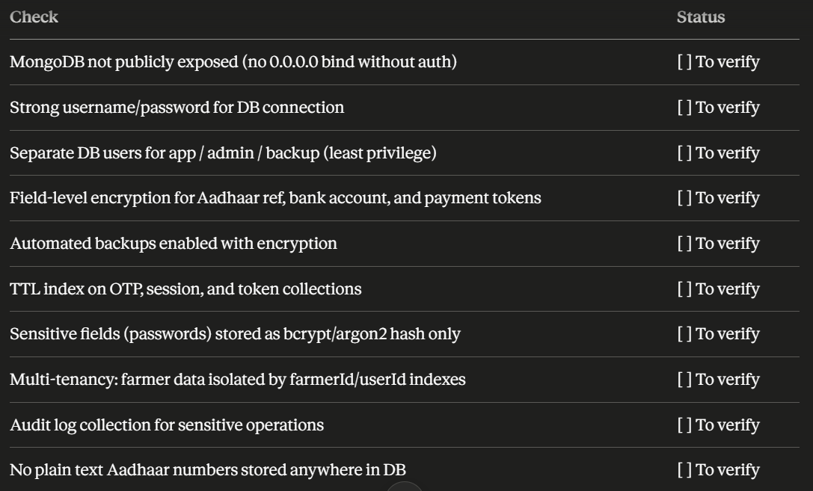

MongoDB Database User Separation
Never connect to MongoDB using a single all-permissions user. Create separate users with scoped permissions:
// Create in MongoDB shell — run once during infrastructure setup

// App user — only what the application needs
db.createUser({
user: "eartigo_app",
pwd: "<strong-random-password>",
roles: [{ role: "readWrite", db: "eartigo_prod" }]
});

// Admin user — only for schema migrations and admin tasks
db.createUser({
user: "eartigo_admin",
pwd: "<strong-random-password>",
roles: [{ role: "dbAdmin", db: "eartigo_prod" }]
});

// Backup user — read-only for automated backups
db.createUser({
user: "eartigo_backup",
pwd: "<strong-random-password>",
roles: [{ role: "read", db: "eartigo_prod" }]
});

TTL Indexes — Auto-Expiry for Sensitive Temporary Data
OTP codes, session tokens, and password reset tokens must expire automatically. Never rely on application code alone to clean these up — a crashed job leaves sensitive data indefinitely.
// OTP collection — expires 10 minutes after creation
db.otps.createIndex({ createdAt: 1 }, { expireAfterSeconds: 600 });

// Session collection — expires 7 days after last activity
db.sessions.createIndex({ lastActivity: 1 }, { expireAfterSeconds: 604800 });

// Password reset tokens — expires 1 hour after creation
db.password_resets.createIndex({ createdAt: 1 }, { expireAfterSeconds: 3600 });

Multi-Tenancy: farmerId/userId Index Enforcement
Every collection that stores farmer-specific data must have a compound index on farmerId/userId. This enforces data isolation at the database layer, not just the application layer, and ensures queries cannot accidentally cross tenant boundaries.
// Enforce in every farmer-scoped collection
db.farms.createIndex({ farmer_id: 1 });
db.crop_assessments.createIndex({ farmer_id: 1, farm_id: 1 });
db.iot_readings.createIndex({ farmer_id: 1, farm_id: 1, timestamp: -1 });
db.yield_estimates.createIndex({ farmer_id: 1, season: 1 });
db.payout_records.createIndex({ farmer_id: 1, created_at: -1 });

// ALWAYS include farmer_id in queries — never query by farm_id alone
// BAD:
const data = await CropAssessment.find({ farm_id: req.params.farmId });
// GOOD:
const data = await CropAssessment.find({ farm_id: req.params.farmId, farmer_id: req.user.id });

Sensitive Fields — What NOT to Store
This is a hard rule table. If any field in the Avoid column is found in plain text in any Eartigo database collection, it is a critical security incident and must be treated as such immediately.
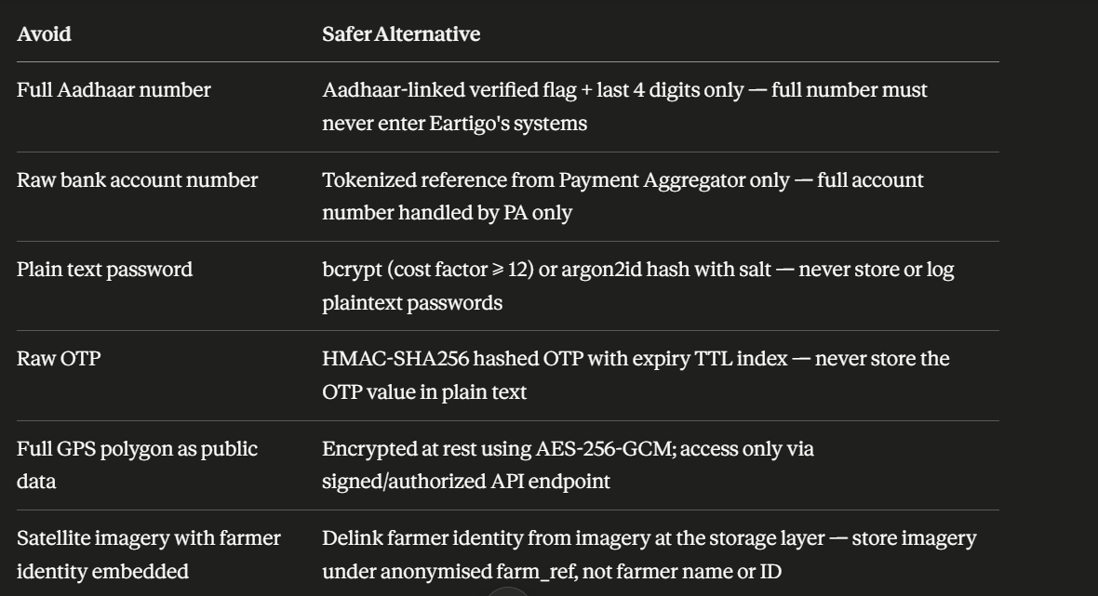
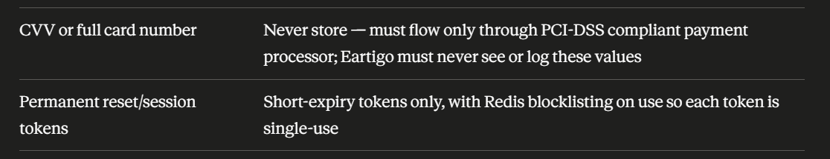

Password Hashing Implementation

const bcrypt = require('bcrypt');
const ROUNDS = 12; // minimum cost factor — increase to 14 for admin accounts

// On registration or password change
const hash = await bcrypt.hash(plainTextPassword, ROUNDS);
await User.updateOne({ _id: userId }, { password_hash: hash });
// Never store plainTextPassword anywhere — not in logs, not in DB, not in a temp field

// On login
const isValid = await bcrypt.compare(req.body.password, user.password_hash);
if (!isValid) return res.status(401).json({ error: 'Invalid credentials' });

OTP Hashing Implementation

const crypto = require('crypto');

function hashOtp(otp) {
return crypto.createHmac('sha256', process.env.OTP_HMAC_SECRET)
.update(otp.toString())
.digest('hex');
}

// On OTP generation — store only the hash
const otp = Math.floor(100000 + Math.random() * 900000).toString();
const otpHash = hashOtp(otp);
await OTP.create({ phone: req.body.phone, otp_hash: otpHash, createdAt: new Date() });
// Send plain OTP to user via SMS — never log it
sendSms(req.body.phone, otp);

// On OTP verification — hash the submitted value and compare
const submitted = hashOtp(req.body.otp);
const record = await OTP.findOne({ phone: req.body.phone, otp_hash: submitted });
if (!record) return res.status(401).json({ error: 'Invalid or expired OTP' });
await OTP.deleteOne({ _id: record._id }); // Single use — delete immediately on success

File Upload Security

const multer = require('multer');
const FileType = require('file-type'); // magic bytes validation

const ALLOWED_TYPES = ['image/jpeg', 'image/png', 'application/pdf'];
const MAX_SIZE_MB = 5;

const upload = multer({
storage: multer.memoryStorage(),
limits: { fileSize: MAX_SIZE_MB * 1024 * 1024 },
fileFilter: (req, file, cb) => {
// Extension check — first layer only, not sufficient alone
if (!ALLOWED_TYPES.includes(file.mimetype)) return cb(new Error('Invalid file type'));
cb(null, true);
}
});

// In route handler — magic bytes validation (second, definitive layer)
router.post('/upload', authenticate, upload.single('file'), async (req, res) => {
const detected = await FileType.fromBuffer(req.file.buffer);
if (!detected || !ALLOWED_TYPES.includes(detected.mime)) {
return res.status(400).json({ error: 'File content does not match declared type' });
}
// Only upload to S3 after both checks pass
await uploadToS3(req.file.buffer, `farms/${req.user.farmerId}/${Date.now()}`);
res.json({ success: true });
});

NoSQL Injection Prevention
MongoDB is vulnerable to injection attacks when user-supplied objects are passed directly into queries. The following patterns are mandatory.
// BAD — attacker can pass { "$gt": "" } as the username and bypass auth
const user = await User.findOne({ username: req.body.username, password: req.body.password });

// GOOD — validate and sanitise inputs first; use parameterised field access
const { error, value } = loginSchema.validate(req.body);
if (error) return res.status(400).json({ error: 'Invalid input' });

// Cast explicitly — never pass raw req.body object into a query
const user = await User.findOne({ username: String(value.username) });
const isValid = await bcrypt.compare(value.password, user.password_hash);

Additionally, install and apply express-mongo-sanitize as a global middleware to strip $ and . characters from all incoming request data:
const mongoSanitize = require('express-mongo-sanitize');
app.use(mongoSanitize()); // Apply before all route handlers

API Security Implementation Checklist

